A unified approach to personal happiness
in Microsoft Teams

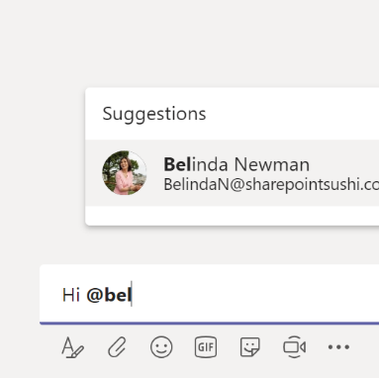
If you expect a response from someone, you should @mention that person.
Only when you @mention someone, that person will be notified of your message. The @mentioned person will receive a notification in the Activity feed and if that person has not read the message within 90 minutes, an additional email will be sent to that person (unless that person has disabled email notifications of course, more on that topic later).

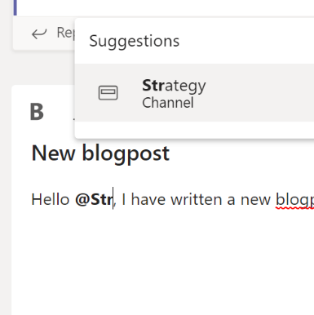
Moreover, don’t assume someone has read a conversation unless that person (or the Team/Channel) has been @mentioned.
Not everyone is following all the same Channels as you do or monitoring their Teams as closely as you do. When you did not @mention a person, a Channel or an entire Team, you cannot assume that someone has actually read the conversation. They might, but you are not allowed to assume so.

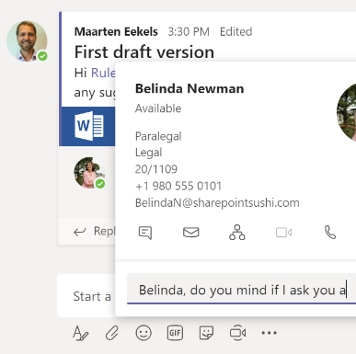
If you have a personal question for someone, use the Chat functionality
Personal questions are meant to be kept personal. Also, they might clutter a conversation. Other people might drop out of a conversation if it becomes a 1-on-1, which might degrade the value of that conversation. Also, it might make it harder for new joiners of a conversation to find the relevant information in that conversation.

Give your Chats a title to bring some structure to them
You can use Chat for 1-on-1 conversations, but also to have conversations with up to 20 people (soon to be expanded to up to 250 people). One of the very nice features of 1-on-many Chat conversations is that you can give those a title. Especially very convenient if you have multiple Chat conversations about different topics with the same people. This helps you in structuring your Chat conversations.
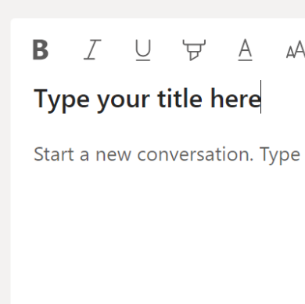
Start new conversations with a title
When you first see a new conversation in a Channel, it might not be obvious right away what the conversation is about. Titles really help when you are quickly scanning all the new conversations. A title gives a very good indication of the contents of the conversation and saves time in deciding if you want to join a conversation or not. Click the Format button to open a compose box where you can add a title to a conversation.

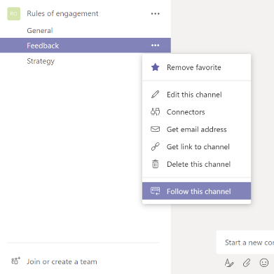
Follow channels to track activity in your Activity stream
There is a difference in Teams between favouriting a Channel and following a Channel. When you favourite a Channel, it will stay visible in your list of Teams and Channels. But you still have to visit that Channel to find out what is happening there. When you follow a Channel, you received direct notifications in your Activity stream when there is new activity in that Channel. And even better, you can then filter your Activity stream to display all activity in all the Channels that you follow. Click and then

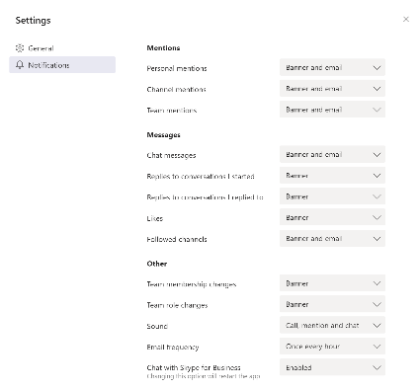
Tune your notifications
When you have joined several Teams and activity starts to increase, you might be overwhelmed with the number of toast notifications the Teams client creates and by default you will receive emails every hour (if any activity has occurred). You can (and should) tune your notification settings to your liking. You can do so by clicking your profile pictures in the top right corner, then Settings, and then Notifications.

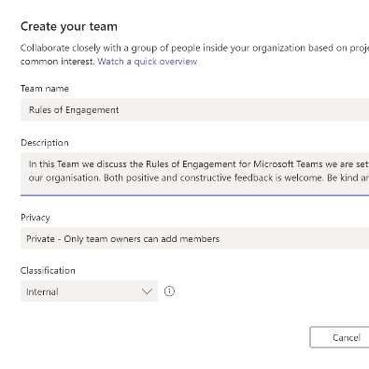
Search for an existing Team before you create a new Team
When you want to work together in a team around a certain topic, and you would like to create a Team in Microsoft Teams to facilitate that, it might very well be possible that a Team around that topic (or a similar topic) already exists. Therefore, it is good practice to search if such a Team already exists, before you create a new Team. Keep in mind that the search only works for Team names that start with your search term. Unfortunately, it is not possible to search using wildcard search right now. When you do create a new Team, always define that Team’s purpose and set a
description for the new Team.

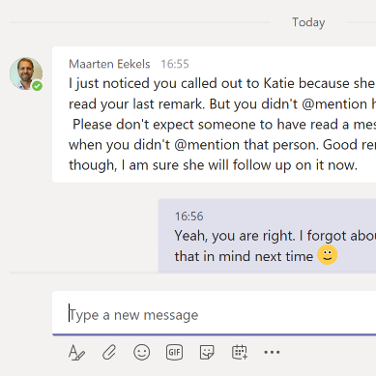
Help each other in using Teams the “right way”
These “Rules of Engagement” are meant to help you and your co-workers in finding “the right way” to use Microsoft Teams in your organisation. A set of agreements helps in what you can expect from each other. But we are all humans (well, except for the bots in Teams). Don’t be afraid to suggest different behaviour but be kind and polite (even use Chat if you think that helps). Also, don’t be angry when different behaviour is suggested to you. We are here to help each other and offering help is usually with good intentions.

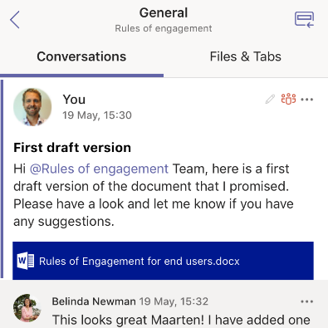
Use both the desktop and mobile clients
One of the reasons why Microsoft Teams is such a great product, is its mobile platform. Both for iOS and for Android, there is an excellent Teams app available. It is performant, intuitive to use, and works together well with Word, Excel, PowerPoint and OneNote. It provides a great way to keep up with your Activity stream and to participate in conversations. You can download it for free from the App Store and Google Play.

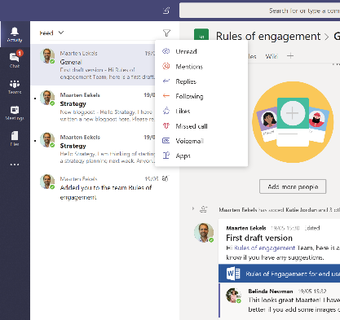
Build a daily ritual among alerts, chats and channels
More often than not, we hear that people are overwhelmed by the number of alerts and conversations taking place. This is a normal experience when you just start using Microsoft Teams. Teams provides a new way of collaborating to many, and it takes a bit of time and building a habit to optimise your use of it. Of course, all the rules mentioned above are meant to assist you in leveraging Teams to its fullest potential as well, but best of all is to embed the use of Teams in your daily work pattern. Just as you probably have already done with email.

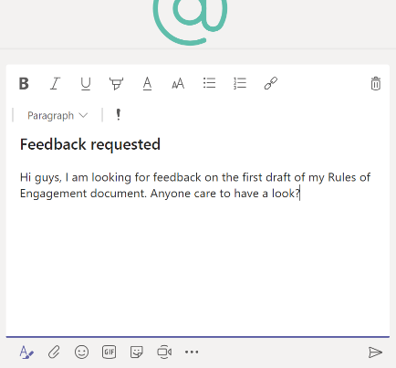
Stop emailing, start conversations!
You just clicked the New Email button in Outlook. But ask yourself, do I really need to send this message out through email? Wouldn’t a conversation on Microsoft Teams make much more sense? With a conversation in Teams, you might get insights from co-workers you would not have expected it from and you would never have gotten through email because you would have omitted them from the email conversation in the first place. Also, on Teams you might inform co-workers that you wouldn’t have informed through email. Sounds good? Use Teams!

